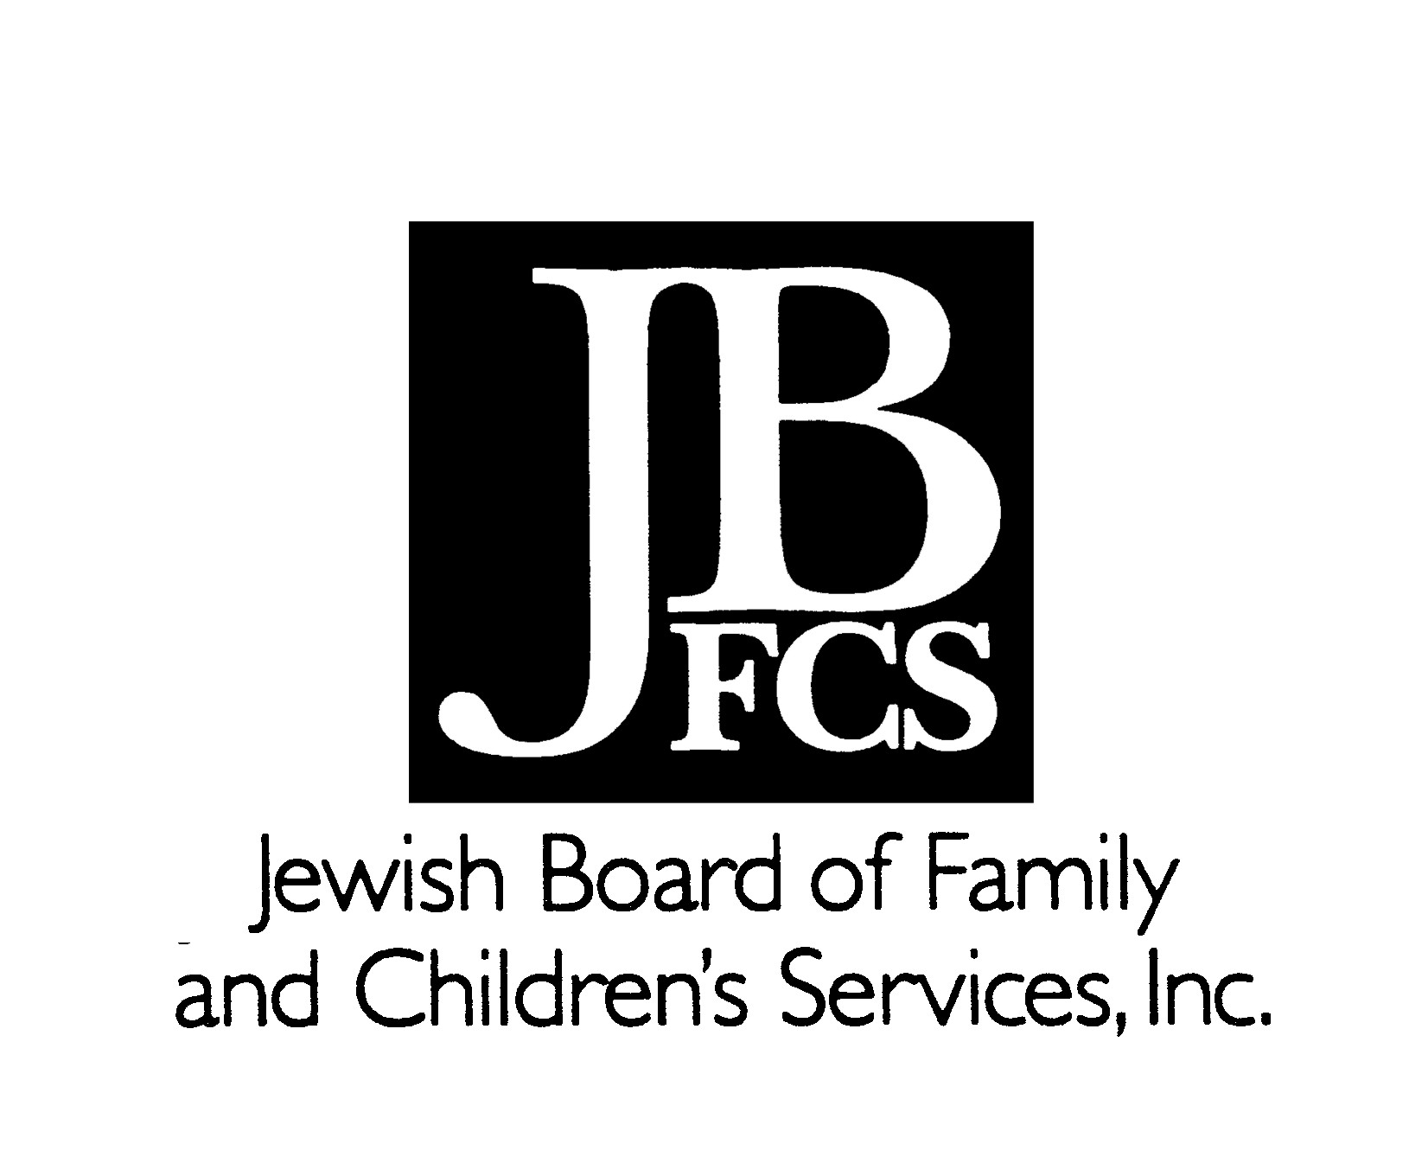
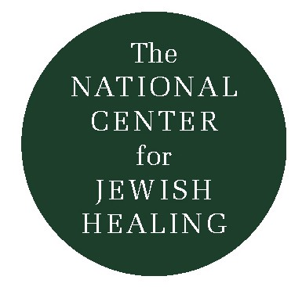
To Join Heaven and Earth
Maimonides and the Laws of Bikur Cholim

Rabbi Tsvi Blanchard describes himself as a person who lives and breathes traditional study, and who continually turns to Jewish texts as a way of deepening his response to those who are ill. One text that he has found to be especially rich is that section of Maimonides’ Mishnah Torah which deals with the mitzvah of bikur cholim, visiting the sick. The following is an excerpt from a commentary that he has written on that text for the Jewish Healing Center.

Introduction

Illness, whether our own or someone we care for, has a way of focusing our attention on the essential issues by calling into question the conventional beliefs we use to hide from our own vulnerability. Illness punctures our defenses, leaves us wide open and exposed to a welter of emotions; we are prey to our imagination and to our fears; we feel weak and powerless.

As we scramble to confront the practical problems that illness brings, we find ourselves pondering the seeming imponderables about the meaning of our lives and our relationships. We perceive, however dimly, that we need to be healed; and not just physically, but more profoundly, spiritually as well. I have come to believe that surprising opportunities to heal are all around us. We need only to be open to them. Read through the text and react to it.

Mishnah Torah, Chapter 14

It is a positive rabbinic commandment to visit the sick…(It is) an act of chesed (lovingkindness), done with one’s body and has no fixed requirement… (It is) included in the commandments, “And you shall love your neighbor as yourself,” that is, anything you wish others to do for you, do the same for your brother in Torah and mitzvot.

Visiting the sick is a mitzvah that everyone is obligated to perform…The more one visits, the more praiseworthy it is, as long as this does not bother the patient.

When one visits the ill, it is as if he takes away a portion of the patient’s illness and lifts the burden of the illness.

When one does not visit the sick, it is as if he has shed blood.

When visiting the sick, one should not sit on the bed or on a chair higher than the patient nor above the head of his bed.

But one should wrap himself up, sit below the head of the bed, request divine mercy on the patient’s behalf, and (only then) leave.

Commentary

In order to motivate us to perform the mitzvah of visiting the sick, Maimonides underscores its importance by declaring the act as beyond gender and social status, limited only by practical considerations, and endowed with great healing powers: a personal communal and divine response to human vulnerability. In the face of illness, friends and supporters come not only as individuals, but as part if a communal response to need. And that response embraces practical action to alleviate pain and suffering, concern for human dignity, and reaching out for divine mercy and support.

To be human is to be vulnerable. All of us, sick and well, share the pain, fear and terrifying powerlessness inherent in that fact. But sharing our vulnerability gives us a way to understand and support each other. God shares with us our moments of vulnerability and supports us in facing that pain, fear and powerlessness.

When we visit the sick, we not only share our common vulnerability, but we identify with G’d through a supportive presence; we are “there” for the sick person, just as G’d “is there.” Thus, in visiting the sick, we become both more human and more G’d like.

Why do we perform this mitzvah? Halachically, visiting the sick is part of a wider commitment to love our neighbor, either because we have become aware of our own needs, and therefore, feel responsible for meeting our neighbor’s needs; or we may do so because we recognize that at some important spiritual level, all human beings are the same and must be loved as such. Or we may love our neighbor because of our search for the holiness and our desire to do the will of G’d who has given us this mitzvah.

As with all commandments, visiting the sick takes us beyond ourselves without demanding that we leave ourselves behind. We can both rediscover ourselves and connect to the person we have come to visit as we understand the shared humanity that transcends time, place and circumstance. Ultimately, through the performance of this mitzvah, we may suddenly find a holy place where heaven and earth join, at the very spot on which we are standing together with the person who is ill.
Rabbi Tsvi Blanchard
Senior Teaching Fellow and
Manager of Institute at CLAL
The Outstretched Arm
Vol. IV, No. 1, Fall 1994

