
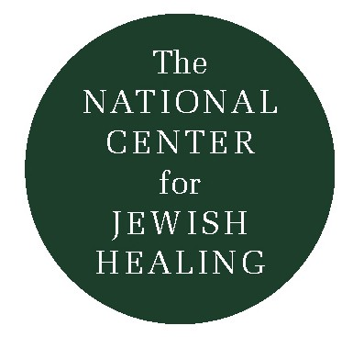
Visiting Those Who are Ill…
“What Do I Say?”

Q: I am about to visit a friend who has just been diagnosed with a very serious illness; what do I say?

A: Visiting someone who is seriously ill can be anxiety-provoking. To be with a person who is ill can stir up many strange feelings: our own fears of sickness and death, sadness we suffered when a loved one died, or discomfort with what is unfamiliar. Often we feel at a loss of words when we see this person in such great distress. Or, we may feel nervous that we will say something that will “make the situation worse.” For all these reasons, it is understandable that one would want guidance in saying the right thing.

The truth is, however, that there is no “right” thing to say. Nothing you can say will shrink the tumor, remove the fear, or “make things the way they used to be.” What you can do is be present with this person wherever he/she happens to be; this is the spiritual gift you bring when you fulfill the mitzvah of bikur cholim.

Being present is what bikur cholim is all about. By visiting, we hope that the one who is sick feels less isolated, more loved, and more truly in the company of God; our presence should be a vehicle for magnifying the person’s feeling that God is near. In the laws of bikur cholim we learn that God’s presence (the Shechinah) dwells at the head of a sick person’s bed, and that therefore we are not to sit there. I understand this halacha as a metaphorical teaching: whatever we say or do when we visit, we should make sure that we are not an obstacle to the Shechinah! We should not be focused on our own agenda or desire to find the “right” words that we fail to be present with our loved one.

In order to be lovingly present with another person, we must learn how to
quiet our own internal dialogue (“He looks awful… Why isn’t she angry
about what’s happening? She must be in denial… I wish I hadn’t just said
that… Why is he talking about the football game?). We must learn to be
aware of those times when our own agenda, judgements, or
preoccupations interfere with our ability to stay present with the thoughts
and feelings or the person whom we are visiting.

To establish connection and be present with our friend, relative, or
neighbor, not only is it helpful to quiet our own internal dialogue, but also
to follow the person’s lead in conversation; to be able to listen; to be
comfortable with silence; to be willing to communicate non-verbally; to be
willing to show love; and to be oneself. In the course of visiting, we might
say, “I love you;” “I’m sorry that this happening to you;” “I’m here for you;”
or “I’ll pray for you/you’ll be in my thoughts.” Such comments can express
true love, care and respect.

Although there is nothing magical to say to someone who is seriously ill, it
is usually not helpful to say: “Cheer up;” “Don’t feel/upset/angry/
depressed/sad…” “It could be worse/count your blessings.” “It’s God’s
will/God gave you this for a reason” or “It’s going to be okay (you usually
do not know this).”

Remember that what you say is less important than who you are. Your
presence really says it all.

Rabbi Nancy Flam

The National Center for Jewish Healing

Acts of Loving-Kindness

A Training Manual For Bikur Cholim
1994


