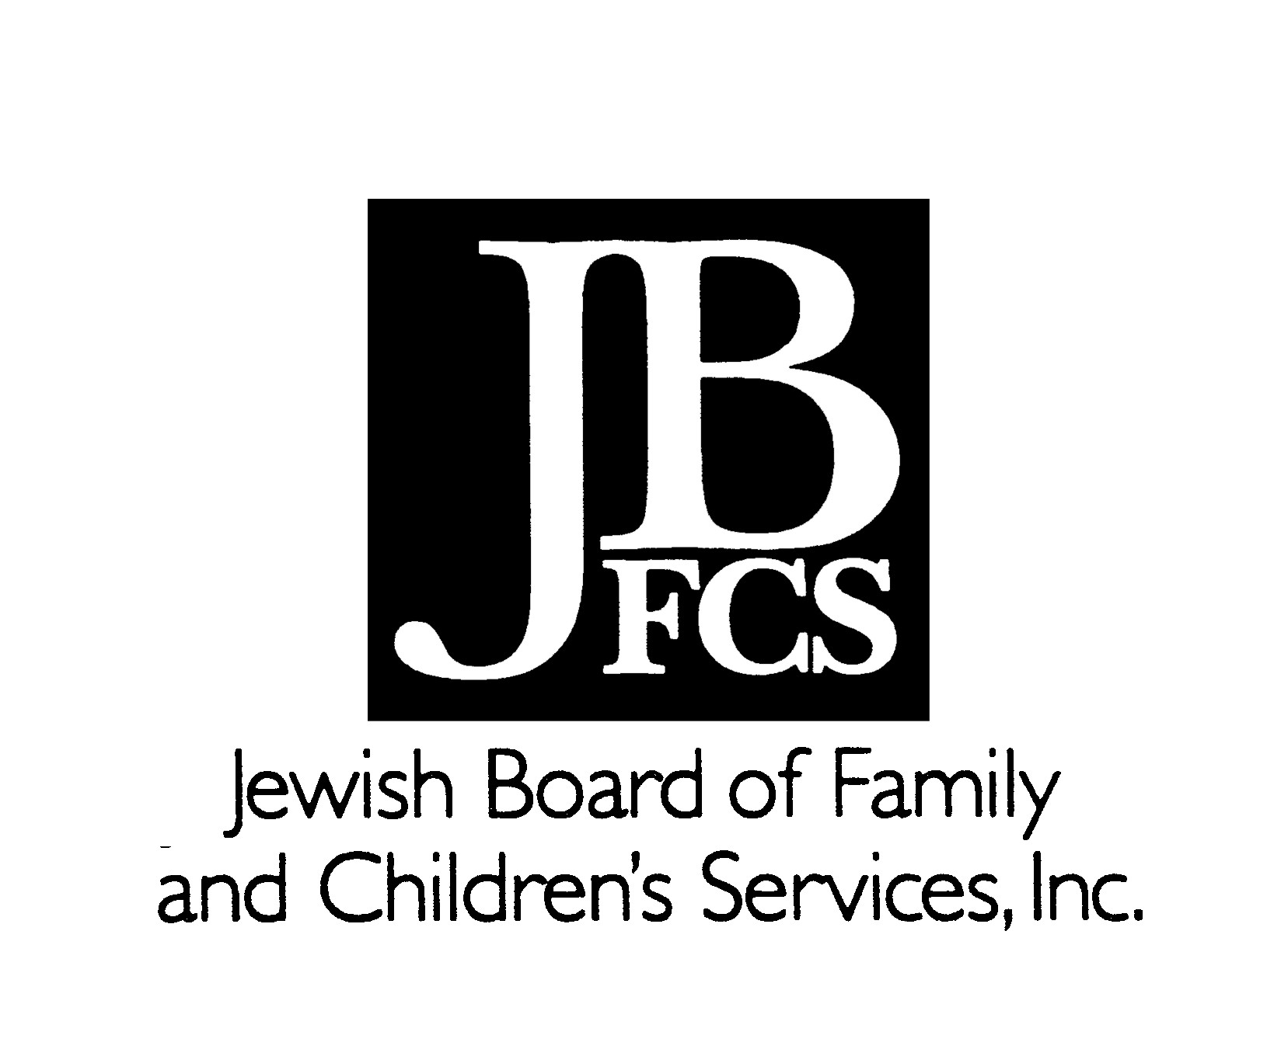
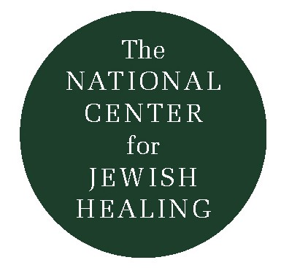
WHAT IS BIKKUR HOLIM?
ACTS OF LOVING-KINDNESS
NCJH TRAINING MANUAL FOR BIKKUR CHOLIM

By Rabbi Nancy Flam, Rabbi Janet Offel and Rabbi Amy Eilberg

One of the central resources of Jewish tradition for those who are ill is the mitzvah bikkur cholim (“visiting the sick”). The essence of the mitzvah is to be with the person who is ill, and to address both that person’s physical and spiritual needs. Because one’s natural tendency at a time of illness is toward isolation (physical, emotional and spiritual), this mitzvah helps the ill person mitigate his or her own isolation.

The essence of the mitzvah is to be with the person who is ill and to share some of the burden he or she may be feeling. The Talmud asserts that a truly empathic visitor may help lighten the ill person’s burden just a bit. (1) A visitor should offer his or her full attention and loving kindness, providing his or her simple and profound human presence as a gift.

Bikkur cholim is a mitzvah incumbent upon every Jew, not just upon the rabbi or cantor of a congregation. Not only does this make sense from the perspective of human economy (as it would be hard for one or two people to serve an entire congregation in this manner), but it also makes sense on another level; visiting often affects the visitor as much as it affects the person being visited. When we as visitors are truly present to another human being in pain, we are often softened, made more compassionate, and at times made more aware of our own blessings. If every member of the community takes it upon him or herself to visit the ill, then the entire fabric of the community may be changed. We then create more loving, care and connected Jewish communities.

Bikkur cholim is an act which we are told is performed even by God, who visited Abraham when he was recuperating from his circumcision. (2) When we perform the mitzvah of bikkur cholim, we are acting in the image of God and modeling ourselves on God’s behavior.

As Rabbi Tsvi Blanchard notes in Joining Heaven and Earth: Maimonides and the Laws of Bikkur Cholim, “Visiting the sick is a moment which unites human generosity with the nurturing Divine Presence.” In performing this mitzvah, we reach out both to the human and the divine worlds: at the same time offering our human presence and praying for God’s healing. The act of bikkur cholim invites God’s presence into the world.

Rabbi Blanchard teaches that a bikkur cholim visit can, in its highest form, offer us the opportunity both to connect to the person we have come to visit, and to deepen an aspect of our own selves. At such moments, we may understand our underlying, shared humanity with the one being visited, linking us with the

- Talmud Bavli, Nedarim 39b
- Talmud Bavli, Sotah 14a

transcendent. By confronting another person’s illness and praying for his or her recovery, we allow ourselves a tender vulnerability. When visiting one who is ill, whether a close family member or a complete stranger, our defenses are often shaken as we are exposed to a vast range of emotions. Frequently our imaginations and fears run wild: we feel weak and powerless in confronting another’s pain.

Learning the “art” of bikkur cholim involves learning how to share the pain, fear and frightening powerlessness inherent in the fact that to be human is to be vulnerable. Sharing our sense of vulnerability gives us a way to understand and support one another. It is in that shared understanding that we come into contact with the divine.

LEARNING TO DO BIKKUR CHOLIM

Our biblical and rabbinic literature is rich with stories and anecdotes about visits to those who are ill and the prayers that are said for them. The shortest Jewish healing prayer on record is Moses’ simple and direct petition to God, “El na, refa na la; Please God, please heal her,” (3) spoken when his sister Miriam was stricken with leprosy.

In addition to the examples of visiting and praying for the ill that are provided in the Bible and in the aggadic (non-legal) portions of rabbinic literature, we have also inherited explicit rules and guidelines about how to visit the ill. All the major law codes contain extensive instructions about how one is to act in the presence of someone who is ill.

For many centuries, these stories, prayers and laws have formed the building blocks upon which a Jewish understanding and response to illness has been based. When bikkur cholim groups formed in the middle ages, they were guided by these texts. In our own day, as well, with bikkur cholim committees sprouting up throughout the country, we take these texts as the foundation of our bikkur holim practice. In addition, we apply the insights and wisdom of modern psychology to help us better understand the role of the visitor and to feel more comfortable about the act of visiting.

Numbers 12:13



