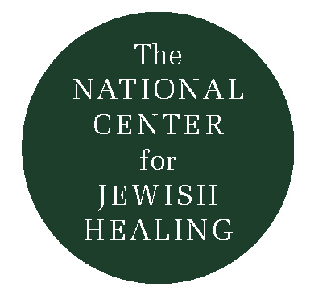
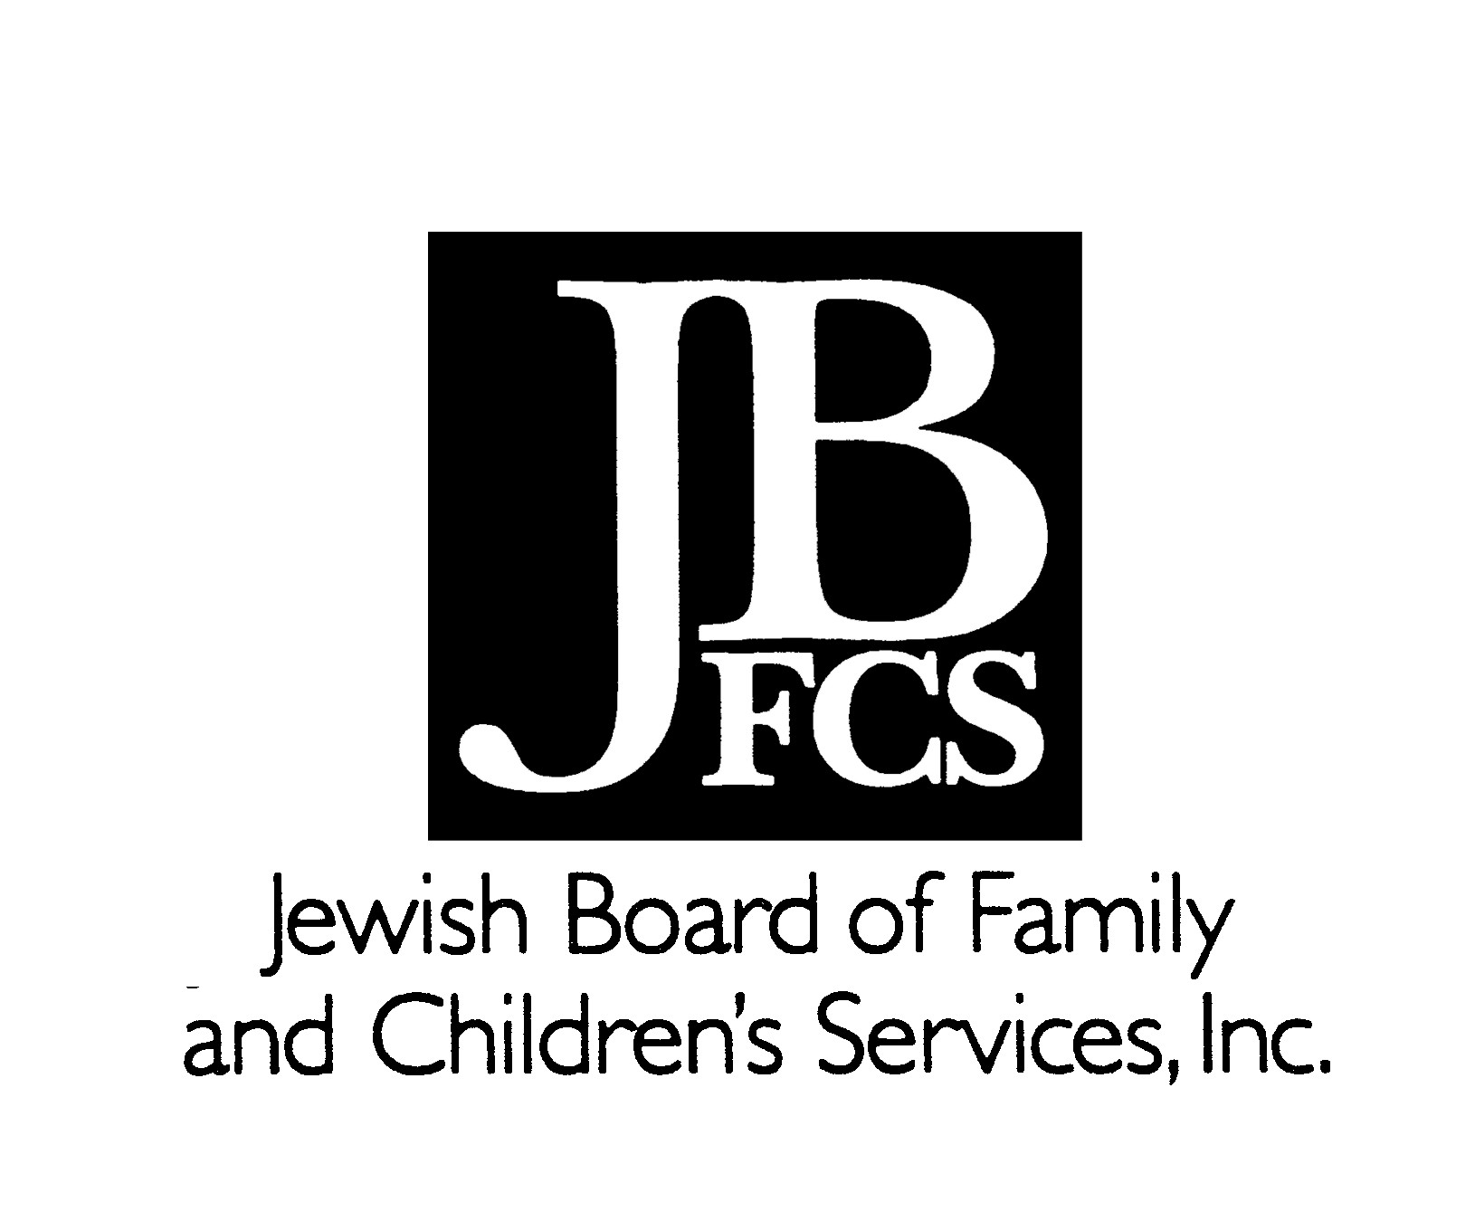

A Leader’s Guide to

Services and Prayers of Healing

Except from the Leader’s Guide, A resource of the National Center for Jewish Healing.

As creators of services and liturgies of healing, we dare to enter the wilderness. Indeed, not one wilderness, but two. The one is the communal wilderness of self-authenticated ritual, where we toil and forage and cobble together words and songs and spaces that attempt to reach powerfully toward the Eternal and each other. The other is the private wilderness of those who come to us for hope and companionship and comfort. As pioneers, we enter we enter this terrain with a mixture of hubris and humility. Hubris, for we act as those who sate together at Yavneh, thinking, believing, that in some way we too stand at the threshold of a enw era of Judaism, and that we participate in its creation. Hubris in thinking that through our presence, that through our words, we can bring healing, to another soul. And yet humility, for who can sit at Yavneh, and who can look into another’s suffering, who can face this marvelous and pain-filled world and not feel humbled. Humility, for we are the recipients of the exquisite gift of trust our congregants, or other seekers, place in us when they enter the space we hope to make sacred with them. And we are humbled by the expectations and doors we may open in the context of these services/

This guide is designed to walk you through some of the issues which may help you in planning and running a service of healing, issues such as how to get started, how to structure the service, what can be expected, what should be included, what would be considered a success, and how to follow-up. Given the fluidity of the state of such services, we welcome hearing the lessons you learn and the insights you develop as you undertake your services.

Introduction

The function of a service of healing is to invite Jews into an environment in which each person can, through prayer, invite God to be in relationship to his or her suffering.

Creating Community & Its Forms of Expression

While each person comes to the service as an individual, the group also gathers as a collective. There may be an element of healing simply in the gathering itself, as one senses that one is not alone, as one feels oneself to be part of a community of sufferers.

In a traditional Kabbalat Shabbat service, there is a particular time when the congregation turns to those who are mourning and greets them with the words “May God comfort you among all who are mourning for Zion and Jerusalem.” This moment acknowledges that within the community there are people in pain, people in mourning. Similarly, the service of healing acknowledges that, among Jews, there are those who are suffering, those who are in pain from life’s assaults. Any human community has its share of physical and spiritual suffering; any authentic Jewish community should find ways to recognize that pain in a Jewish context. The service of healing is one way to bring the truths of people’s lives and their relationships to God into the heart of the community.

The service of healing is a contemporary creation, born of necessity. It is a cry for community in a society which prizes individualism. It is a coming together of those who feel broken and vulnerable in a society which despises weakness, which spurns those who are not (most particularly, economically) “productive.” It takes place in a specifically Jewish context to help Jews connect with the power of a tradition whose traditional liturgy is often inaccessible or uninspiring to those who are not ritually observant.

The service of healing is a new creation. There will be those who are uncomfortable with it for its lack of convention, because it is not Shaharit, Minha or Ma’ariv (though integrating some of the service of healing within a traditional service might provide great richness to those more liturgically conservative). It borrows from different parts of the traditional liturgy and rearranges them. It adds new pieces which invite the voices of individuality rather than the collective alone. It asks that we bring our particular truths to the communal expression of prayer.

What is a Service of Healing?

A Service of Healing provides a structured time and place of prayer, reflection, meditation and communal connection for those who are coping with illness (and other traumas such as accident and assault), with grief and with loss. It draws upon traditional Jewish liturgy (e.g., niggunim, blessings, psalms, Torah study, the kaddish) and liturgically non-traditional texts and activities (e.g., poetry, communal sharing, consciousness of the breath and the body). This mix of traditional and non-traditional liturgy and activity connects the participant to historic Jewish tradition while integrating modern modes of expression, attention and communication. Through such service, one may derive spiritual trength not only from the traditional liturgy, but also from quiet reflection and meditation, and from personals haring and listening.

Theology and Liturgy

While the traditional Jewish prayer service mentions the reality of suffering and our hope for healing, such themes are at the very center of a service of healing. Expressions about God’s relationship to our suffering, anger, grief, hope, solace, and gratitude are knit together to create the fabric of this liturgy.

A service of healing may be constructed with any number of Jewish theologies at its core. Certainly, those who attend bring their won understandings of god and their particular relationship wit the Eternal; the liturgy ought to reflect the needs and beliefs of the particular community it is serving. Some people will come with the expectation that God, an omnipotent, omniscient being, is able to fulfill all prayers; at times this may provide great hope and comfort, at times, tremendous disappointment. Others will come with an understanding of God as the great, life-loving force of creation whose energies may, through such a service, be magnified within to aid in physical and/or spiritual healing. Yet others may find God expressed in the social relationships among participants: particularly, God’s hesed and rahamim as people listen to and care for one another.

What is the Rabbi’s/Leader’s Role

While a service of healing, like any Jewish prayer service, may be led by any qualified member of the community, most services will be led by a rabbi or cantor.

The role of the rabbi will depend upon the particular community’s historic expectations and assumptions about whom their rabbi is to them. Historically, in a Hasidic community, for instance, the Hasidic would expect their rebbe to have an intensely devoted relationship to God, while the Hasidim would have an intensely devoted relationship to the rebbe. In this case, God as expressed through the person and powers of the rebbe might act as healer.

In our own day, a traditional Jew might see the rabbi/leader as shalia tzibur or facilitator, as one of the congregation acting simply to lead the people in their own prayers. In such a view, the integrity and authenticity with which the shaliah tzibur prays certainly has an effect on the prayer experience of those participating. The role of the shaliah tzibur is in no way neutral or passive; a passionate and artful prayer leader has the ability to liberate or shackle the prayer experience of those participating.

Personally, I am most comfortable and theologically committed to seeing the rabbi/leader as shaliah tzibur. In addition, in the modern service of healing where there are elements of silence, reflection, meditation and sharing, I also see the rabbi/leader as the one who “holds” the space, who invites the fullness of prayer and experience by keeping the communal space open, accepting and generous. This latter stance is not entirely different from one which might be maintained by a good therapist. Because of this stance, there will be times when projections of participants’ inner lives will be made upon the rabbi, at which point he or she has the responsibility either to work with the particular individual themselves and/or make appropriate referrals to professionals who can serve the individual.

History

The Jewish service of healing began when Rabbi Yoel Kahn of Congregation Sha’ar Zahav in San Francisco was asked to lead a “model Jewish liturgy of healing” for a conference of the Lay Academy of Episcopal Church of Northern California, “Eastern and Western Paths to Healing,” in April 1988. Originally, he thought there to be no particular Jewish liturgy for healing, with the single exception of the Mi Sheberackh prayer offered in synagogue. Upon reflection, he considered that some of the traditional liturgy might in fact be particularly helpful to someone coping with illness and suffering. So he crafted a “model Jewish liturgy of healing” for that Episcopal conference! (Is this not, perhaps, akin to the response to a number of American Jewish leaders made when asked by the Dalai Lama to explain “the secret of Jewish survival”? Jews had not before crafted responses about “the secret of Jewish survival” or “the healing potential of the liturgy,” but when asked by an “outsider” to do so, thoughtful souls mined the tradition in new ways, yielding many a treasure.)

That service was modified and adopted by his synagogue and used on a periodic basis, until in 1991 it was modified again with the help of the Jewish Healing Center*, which has since been leading it for the Bay Area Jewish community on a semi-monthly basis. With the growth of the Jewish Healing Center, its publications and conferences, more and more congregations throughout the United States have begun offering services of healing.

Conclusion

It is no surprise that late twentieth century American Jews ask that Jewish liturgy speak to us not only as part of a historic community, but also as individuals with private pains and struggles. To live most meaningfully and hopefully with our suffering, we need more than the secular therapeutic culture has to offer; we need a relationship with the Divine. As Jews, we search for places in which God, community and the riches of Jewish tradition may form a nexus of support and solace, of inspiration and hope. The service of healing provides one response to our soul-felt need.

- The Jewish Healing Center, which now no longer exists as such, gave birth to two different organizations in September 1994, Bay Area Jewish Healing Center, which provides an expanded menu of healing programs for the Bay Area Jewish community, and the National Center for Jewish Healing, whose mission it is to guide, nurture, promote and enrich the blossoming efforts of the Jewish healing movement.

Introduction by Rabbi Nancy Flam

(current contact info: spiritualityinstitute.org)
Text by Rabbi Nina Beth Cardin
(current contact info: shleimut.org)
(c) 1994 2nd printing 1998

See National Center for Jewish Healing publications to order

