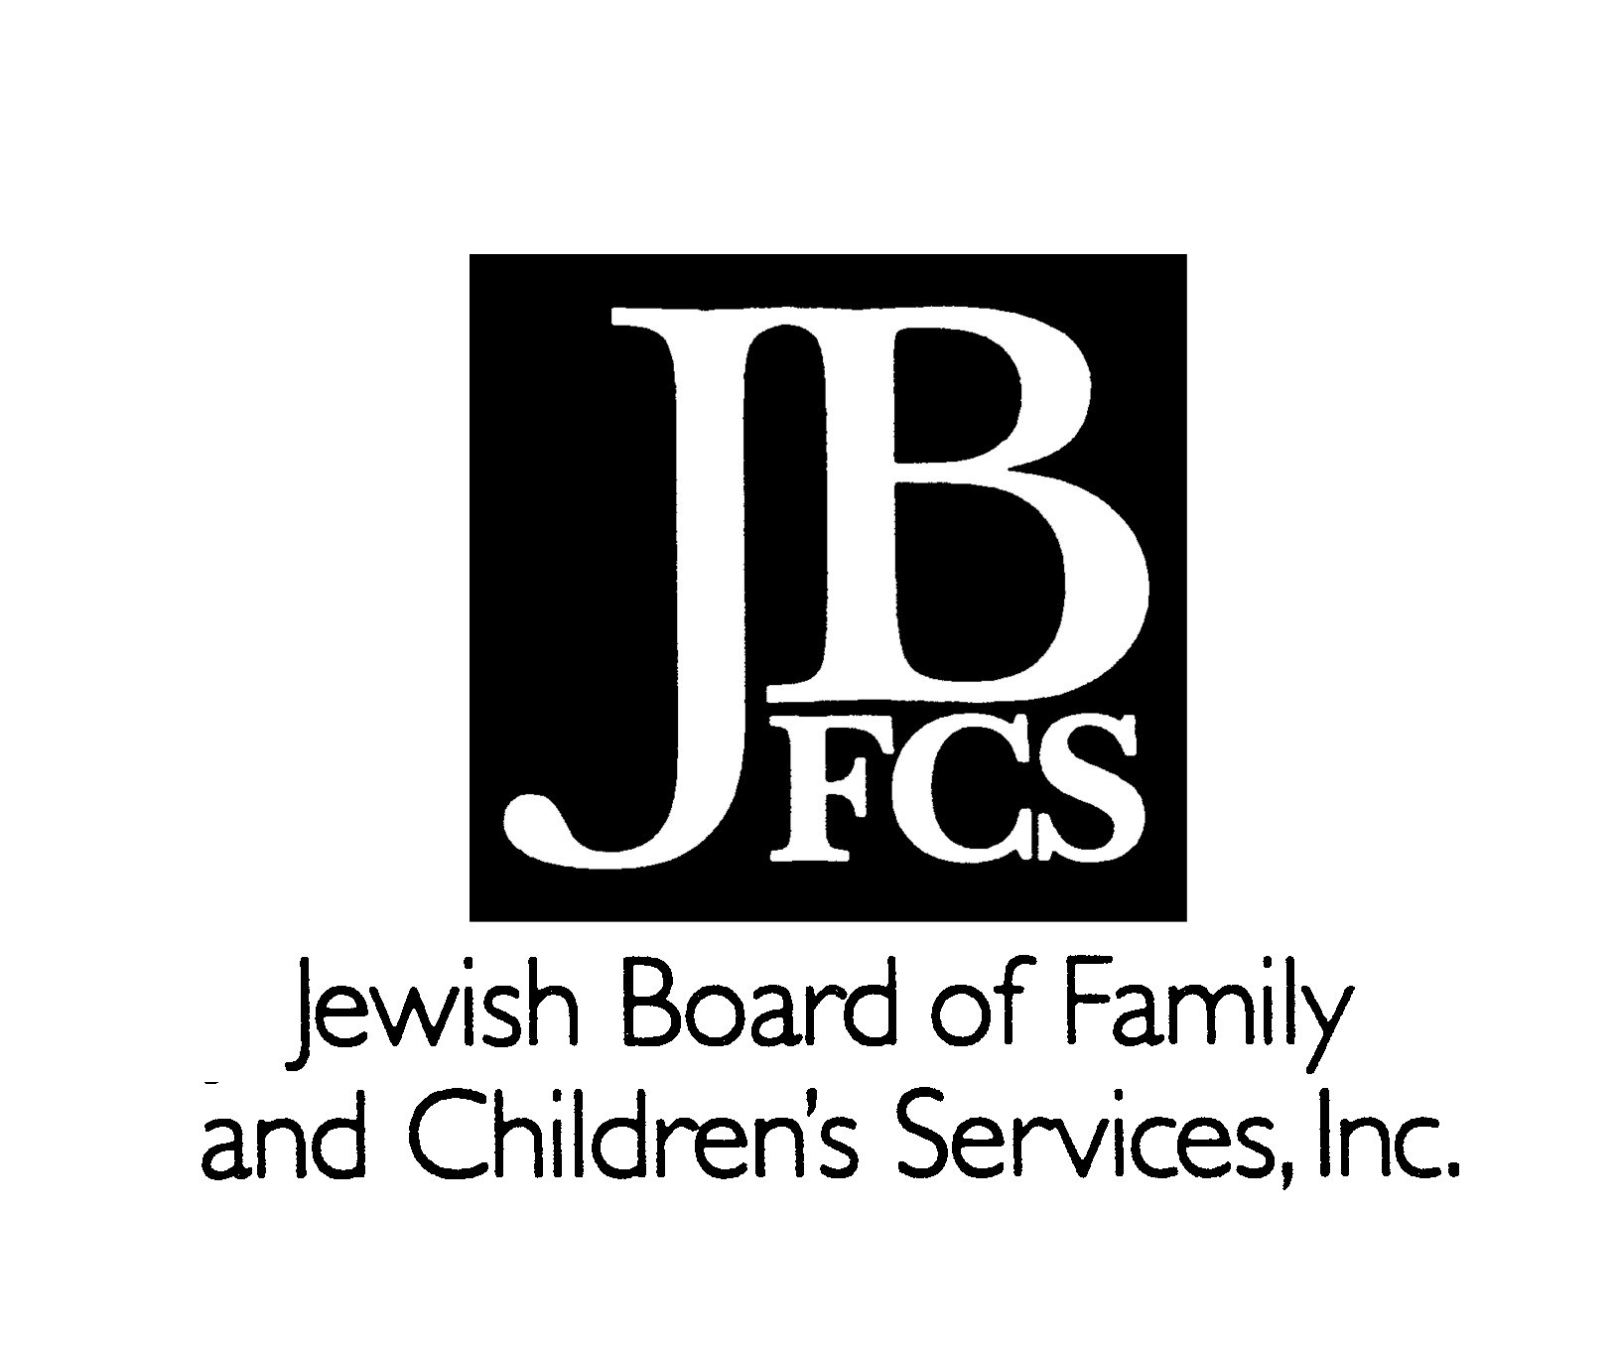
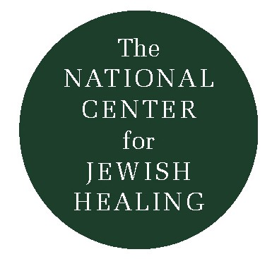
Praying For Healing

Every week for the past nine months, about 25 people have gathered together in San Francisco to pray a special “Service of Healing.” Designed to reach out to Jews struggling with physical illness, it also embraces family, friends, caregivers, and those who seek r’fuat hanefesh – healing of the spirit. The liturgy, inspired by a service created by Congregation Sha’ar Zahav, integrates song, silence, study, and sharing.

Our community is diverse. Some who came are fighting disease: AIDS, cancer, diabetes, hepatitis, mental illness. Some are grieving: for parents, siblings, lovers, friends, clients. Some come to pray for those who cannot come themselves. And still others come in search of an hour’s blessed respite from lives ordinarily too busy for spiritual nourishment.

What are we doing when we gather to pray? Do we really expect our prayers to heal our illness? Or does healing come in the strength, comfort, and guidance we derive from one another? I suspect that the answers to these questions are as numerous as the participants at any given service.

No doubt, there are times when some worshippers pray ardently to God to remove their affliction, much as the psalmist did:

I cry aloud to God
I cry to God to give ear to me
In my time of distress I turn to the Almighty,
with my hand uplifted;
my eyes flow all night without respite;
I will not be comforted.
I call God to mind, I moan,
I complain, my spirit falls. (Psalm 77)

They hope that God will be moved by the fervor of their prayers to take note, intercede, and cure. God is anthropomorphized as a supernatural Being who cares about individual persons and their day-to-day concerns, as a friend or a parent might care. God is thought to be moved by words, and stirred to action in response to our own.

Some worshippers do not believe that God listens to prayers and then chooses whether or not to answer them. Rather, they understand that “our words of worship in no way alter God or change His course of conduct. They can, however, alter us.” (Rabbi Roland B. Gittelsohn) That is, our prayers can remind us of the best in ourselves and inspire us to “rise above our ordinary understandings and accomplishments.” (Rabbi Gittlesohn) Prayer is a self-reflective act: it has more to do with us than it does to do with God. In a wholly naturalistic way, the words of prayer themselves and their being offered in community can bring us strength, comfort, and hope.

Finally, there are times when prayer holds no supplication or expectation, but rather a kind of communing with God, a simple and profound being in God’s presence. Herbert Baumgard wrote that

the Chasidim did not have to ‘think’ about the legitimacy or the efficacy of prayer. They understood it to be as much an essential part of man as his biological urge. They spoke of man’s need to pray in his fashion: When God created the world, He invested a part of Himself (a spark) in everything that He created. These sparks now yearn to re-unite with their source. In this sense, a prayer is the yearning of the divine spark within man to join itself to more of itself…Prayer is God, that is, the divine communing with the divine.

In this paradigm, prayer does not have to do with asking God for something; prayer is the language one uses to make contact with the divine: the divine within, and the divine without. One is focused on the process of prayer, not its product. Simply to be in God’s presence is enough.

No matter how our participants understand their prayers, it is clear that they effect a healing of spirit.
Rabbi Nancy Flam
The Outstretched Arm,
Vol. I, No. 1 Fall 1991
Current contact info:
www.spiritualityinstitute.org



