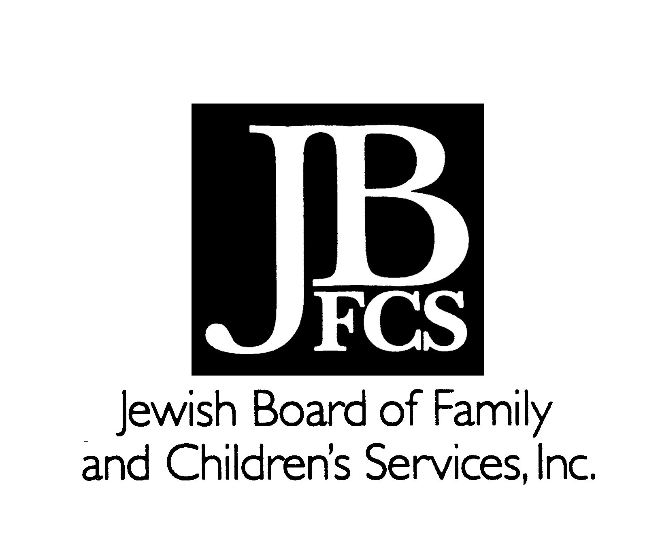
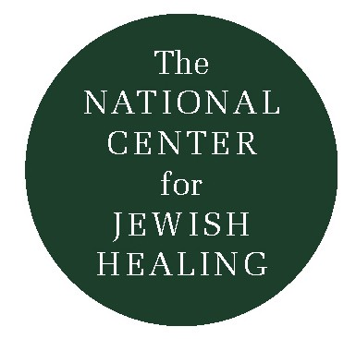
Healing at Bedtime: The Traditional Kriat Sh'ma

For people dealing with illness, bedtime can be a time of both heightened vulnerability, anxiety, and stress, as well as a special opportunity for openness, intimacy, comfort, and reassurance.

Jewish tradition offers a bedtime ritual with some very beautiful and sensitive prayers that can be particularly moving, meaningful, and supportive for those who are ill, their loved ones, and caregivers. Without denying the very real fears and tensions, they can facilitate an ambience of hope, trust, and confidence.

Reproduced below are some elements from the traditional Jewish bedtime ritual, Kriat Sh'ma Al HaMitah, accompanied by an original translation. These prayers, of course, provide a time-hallowed framework for the expression of deep sentiments and profound beliefs, and one should feel free to integrate original, individual prayers alongside them. For many people, simple breathing exercises, repeated chanting of syllables, words, and phrases, and other relaxation/meditation techniques might also prove useful and evocative.

Another priceless resource is the Book of Psalms, which, for centuries, has been a fountain of help and solace for Jews and others in distress. We offer two Psalms below for your consideration.

Rabbi Simkha Y. Weintraub, CSW
Rabbinic Director, Jewish Board of Family and Children's Services

The Sh'ma at Bedtime
(excerpts from the traditional ritual)

Who Closes My Eyes...: A Blessing at Bedtime

Praised are You,
Adonai, our God,
Ruler of the universe,
who closes my eyes in sleep,
my eyelids in slumber.

May it be Your will,
Adonai,
My God and the God of my ancestors,
to lie me down in peace
and then to raise me up in peace.

Let no disturbing thoughts upset me,
no evil dreams nor troubling fantasies.

May my bed be complete and whole
in Your sight.

Grant me light
so that I do not sleep the sleep of death,
for it is You who illumines and enlightens.

Praised are You,
Adonai,
whose majesty gives light to the universe.

The Sh'ma Itself
(Deuteronomy 6: 4-9)

(God is a Faithful Ruler)
Hear, O Israel, Adonai, our God, Adonai, is One.
Blessed be the name of his glorious majesty forever and ever.

You shall love Adonai your God with all your heart, with all your soul, and with all your might. And these words which I command you today shall be in your heart. You shall teach them diligently to your children, and you shall speak of them when you are sitting at home and when you go on a journey, when you lie down and when you rise up. You shall bind them as a sign on your hand, and they shall be frontlets between your eyes. You shall inscribe them on the doorposts of your house and on your gates.

Hashkivenu: "Lie Us Down..."

Lie us down,
Adonai our God,
in peace;
and raise us up again,
our Ruler,
in life.

Spread over us Your Sukkah of peace,
direct us with Your good counsel,
and save us for Your own Name's sake.

Shield us;
remove from us
every enemy, pestilence, sword, famine, and sorrow.

Remove all adversaries
from before us and from behind us,
and shelter us in the shadow of Your wings.

For You are our
guarding and saving God,
yes, a gracious and compassionate God and King.

Guard our going out
and our coming in
for life and peace,
now and always!

A Prayer for Protection at Night

In the name of Adonai
the God of Israel:
May the angel Michael be at my right,
and the angel Gabriel be at my left;
and in front of me the angel Uriel,
and behind me the angel Raphael...
and above my head
the Sh'khinah (Divine Presence).

From the Winter 1992-93 The Outstretched Arm
by Rabbi Simkha Y. Weintraub, CSW (C) 1992
