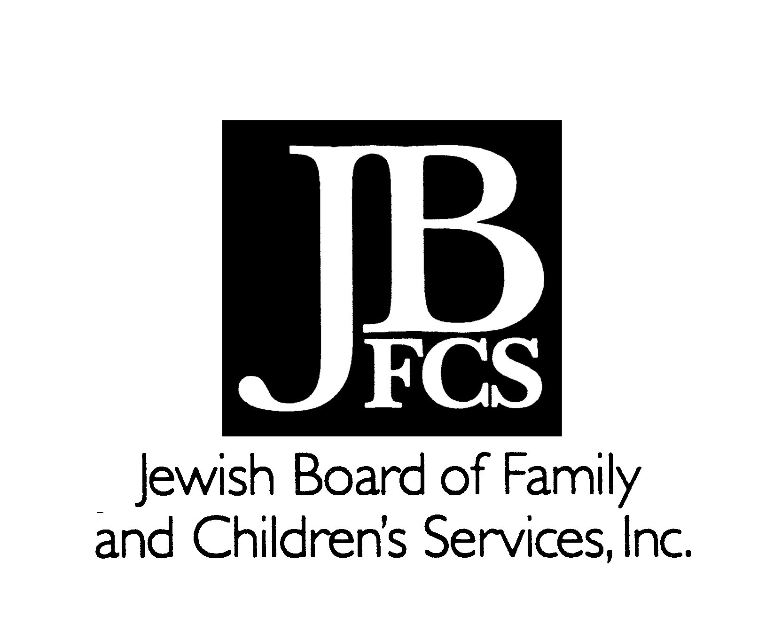
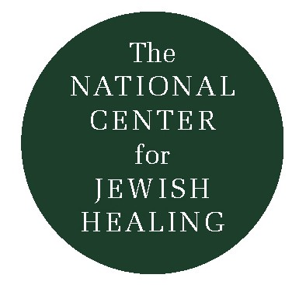
Help from the Healer of Hanipole

An ill man was told to undergo a somewhat risky medical procedure, and came to his rabbi, the Rabbi of Czernobl, for advice, support, and blessing.

“I suggest that you consult with the great healer, the Professor in Hanipole,” the Rabbi advised. (In nineteenth-century Europe, the most competent and acclaimed physicians held professorships in medical schools.)

Now Hanipole was a tiny village, and when the man arrived there, he discovered that not only was there no medical school, there was not even a doctor in the whole community! He returned to Czernobl, totally bewildered.

“There is no Professor in Hanipole,” he told the Rabbi. “Why, they have not doctor at all!”

“Then what do the residents of Hanipole do when they get sick?” the Rabbi inquired.

“What can they do, Rabbi?!” the man replied. “All they can do is lift up their eyes and voices to God, to heal them.”

“Ah, ah – that is what I thought. Seek help from the One who heals the people of Hanipole.”

Reworked by Rabbi Simkha Y. Weintraub, CSW
