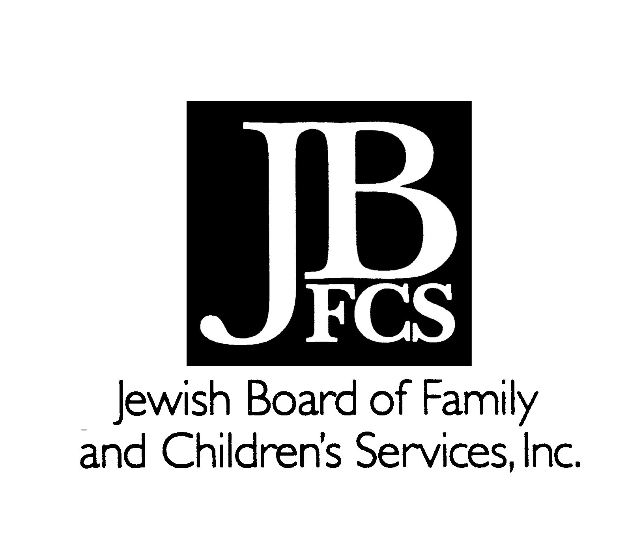
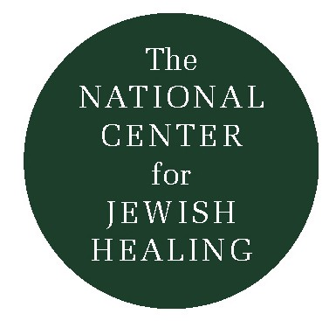
Maggid – A Personal Journey

by Ellen Schecter

Ellen Schecter is a writer, producer, and educator who has published more than twenty books for children, and created award-winning media enjoyed by millions of families. A member of a Jewish Spiritual Support Group of the New York Jewish Healing Center, she gave this talk as part of a panel presentation at an event held by the NCJH and the New York JHC. We are grateful that she has given us permission to share her story with all of you. Ellen has also contributed a tremendous amount of her time and creative energy to this issue of The Outstretched Arm. We welcome the gift of her voice and heart to these pages.

For the past 24 years, I have lived with painful, incurable, potentially life-threatening twin diseases: systemic lupus and demyelinating polyneuropathy. During those years I’ve done everything I could to help myself and my family: a plethora of medications, specialists, clinics, and hospitals; several support groups; hypnosis and self-hypnosis; psychoanalysis, psychotherapy, family therapy.

Being a realist, I turned my attention several years ago from a search for curing my body to a quest for healing my spirit. And thus began a spiritual journey which, despite the lack of any previous formal religious education, is taking me deep down to my Jewish roots. The search drew me to Congregation B’nai Jeshurun in New York City, where I’m learning how to pray and study Torah, and learning Hebrew and cantillation in order to become a “Bat Torah” at age 55. As a writer, the discipline of “taming by naming”-pinning down the difficulties of disease in words on a page in order to understand and examine both their profound influences and their limitations-is also a cherished resource in adversity.

As my tandem, journeys into the worlds of illness and Judaism knit inextricably together, I feel a deep need not merely to transcend my experience of illness but to sanctify it. Long ago, I bid farewell to the unaswerable, uninteresting question “Why me?” and replaced it with a new, more important challenge: "What now?” For while I know that I cannot control which cards I might be dealt in my life, I believe it is my profound responsibility to actively choose how to play them.

The call I received last fall from Rabbi Simkha Weintraub of the New York Jewish Healing Center-with his invitation to join a weekly Jewish Spiritual Healing Group-was not merely an answer to a telephone message, but the answer to a prayer: a prayer for the Jewish spiritual tools that will help me create meaning out of affliction; spin straw into gold; and fashion a heart of wisdom.

The essential difference in a Jewish spiritual support group is that our spiritual search in the face of serious illness is illuminated through the prism of Jewish belief, thought, community, ritual, and tradition. Another essential difference is that our search for meaning takes place through study. We are not limited to our own knowledge and experiences, but can hold hands and jump together into a vast sea of teaching and learning: Torah, psalms, midrash, Talmud, Chassidic tales…all treasuries of wisdom Rabbi Weintraub is opening for us.

Yes, there is kvetching – we are Jews after all; and there is that essential “secret handshake of illness”. We know that when our fellow travelers nod and murmur “I know” they really do know. But the specific joy of a Jewish Spiritual Healing Group is that we delve deeper and deeper into the Jewish traditions of healing and practice them not in isolation, but together. What do we do?

We pray together: We explore meanings and modes of prayer as expressions of grief, rage, fear, loneliness, joy, thanks, celebration, and just silence; just being there.

We sing together: Ancient niggunim – wordless melodies that sink into our marrow. When we sing we are part of a sacred chain reaching back thousands of years and forward into the future. This chain of being has particular meaning in the isolation of illness.

We learn how to “unpack” and interpret the myriad moods and meanings of a psalm, thereby obtaining a template for continued exploration of our liturgy in general and within the context of illness.

We study and interpret: often examining the Torah portion of the week. We find meanings and ask questions that take into account the special sorrow and wisdom of people wrestling with illness. Our discussions, for example, of Jacob wrestling the Angel and receiving not only a wound but a blessing and a new name, both raised questions and offered deep, healing revelations.

We discuss: oh, do we discuss! What is the Jewish concept of the afterlife and of the relationship between body and soul? What are the origins and meanings of Jewish death and mourning rituals? What is illness? Does it come from God? Can God take it away? Is it a punishment? Or a function of the fickle finger of fate which needs integration in our spiritual lives?

We learn about the importance of community: Jewish tradition, in its wisdom, dictates that we are not supposed to heal ourselves by ourselves; that I am supposed to turn to my community for strength and solace. Needing this sense of community doesn’t mean I’m a chicken or a kvetch.

Each session of our group is studded with “Aha’s”! The epiphanies differ for each of us, but here are some that resonate deeply for me:

I came to our first meeting the week I finally accepted the fact that I must leave a job I dearly loved because I could no longer force my body to bend to the will of my mind. Our weekly meetings quickly became a point of light as I began to build a new life.

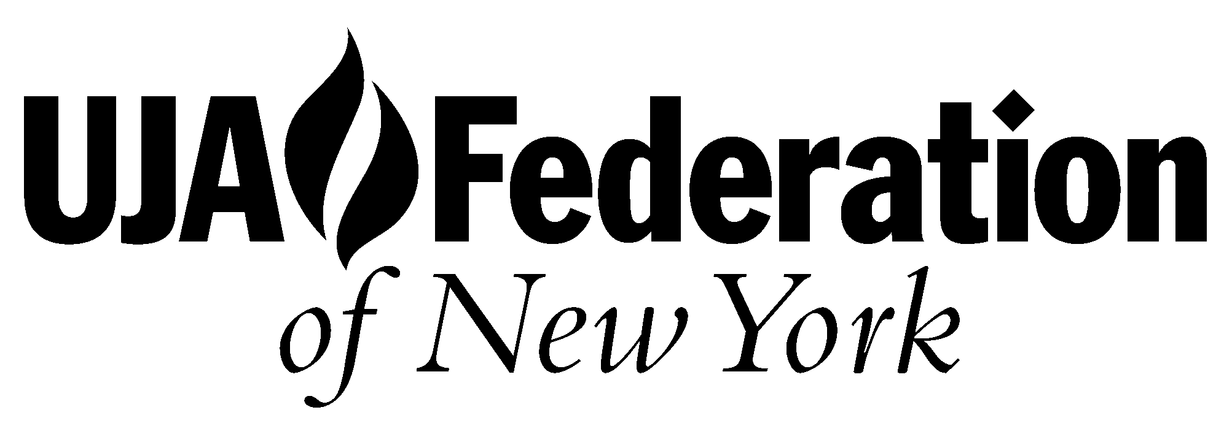
For me, the struggle of the spirit in the face of illness is part of an overall search for meaning and for wisdom, as in Psalm 90: “Teach us to number our days that we may gain a heart of wisdom.” Our healing group enables me to reach out, reach up, and reach inside for glimpses of that wisdom.

The niggunim we sing together weave into my days and my dreams. They rise up out of my bones when I need them most: when the IV needle goes in my hand, and the chemo burns my veins. They are part of my breathing; a thread that connects me to the past and the future at a time when I have cut my usual moorings and feel adrift in the world.

Participating in the Spiritual Healing Group raises more questions than it answers but also gives more comfort, more direction, and more strength than I ever dreamed. Above all, it makes me and my group hungry-very hungry-for more as we come to realize that our Jewish tradition offers sacred opportunities to both acknowledge grief and cultivate joy.

The Outstretched Arm

